Assignment 3



Abdulrahman M Al-Mayouf ID 202002524

Instructor: Dr. Sotirios Zygiaris

BUSI 3331: Business Analytics

3 / 13 / 2024

1. Use the Yahoo_stock.crv and input into Tableau.

Are stock prices affected by volume?

* 1. Define depended and in depended variables.

In this case, the dependent variable would be the **'Close'** price of the stock, and the independent variable would be the **'Volume'** of the stock

* 1. Create regression analysis with the regression line [screenshot]

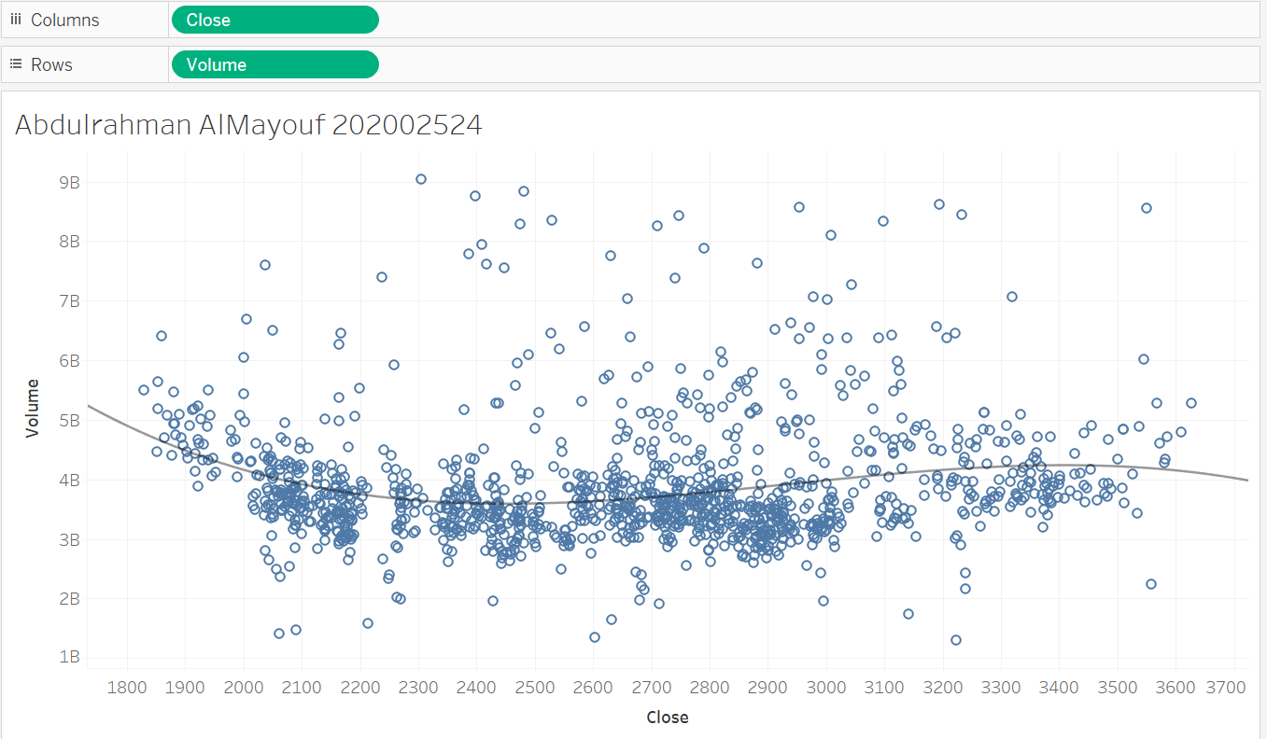

* 1. 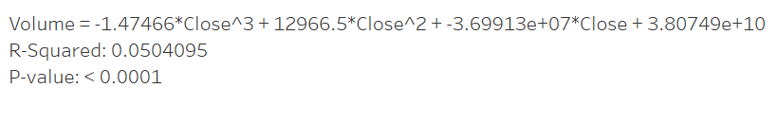Find the regression equation [screenshot]
  2. 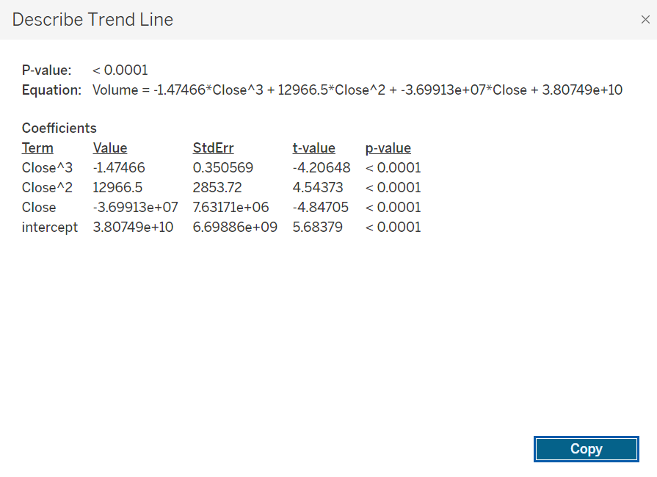Screenshot R2 and the regression details table [screenshot]

1. Use superstore.xls orders worksheet
   1. Is profit related to sales?

Yes, profit is often related to sales.

* 1. Define depended and in depended variables. Find the regression equation [screenshot]

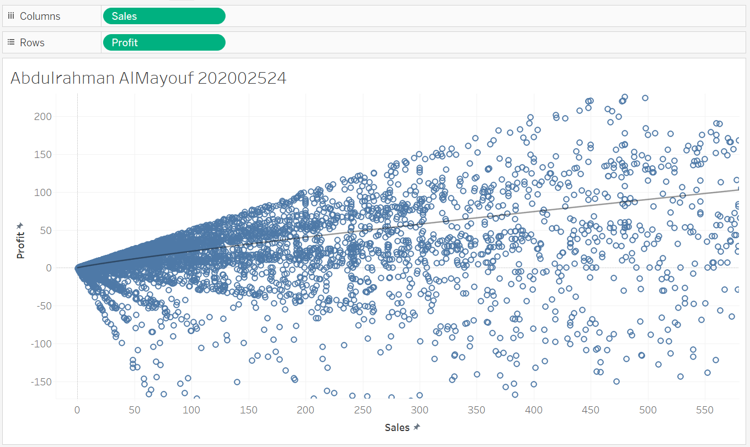

* **Dependent:** Profit
* **Independent:** Sales
  1. Create regression analysis wit the regression line [screenshot] 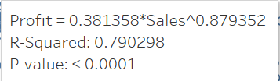  
     Trendl line is **Power**
  2. Screen shot R2 and the regression details table. [screenshot] 